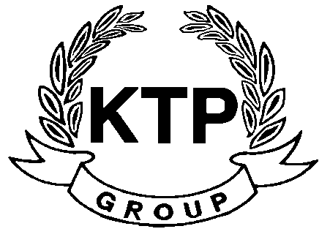
KTP HOLDINGS LIMITED
港台集團有限公司*
(Incorporated in Bermuda with limited liability)
(Stock code: 645)

Suspension of Trading

As the request of KTP Holdings Limited (the “Company”), trading in the shares of the Company has been suspended with effect from 9:30 a.m. on 23 July 2009 pending the release of an announcement in relation to a major and connected transaction.

As at the date of this announcement, the Board is comprised of 5 Directors, of which Mr. LEE Chi Keung, Russell and Miss. YU Mee See, Maria are executive Directors, Mr. NG Wai Hung, LEE Siu Leung and Mr. YUEN Sik Ming are independent non-executive Directors.

By Order of the Board
KTP Holdings Limited
Lee Chi Keung, Russell
Chairman

Hong Kong, 23 July 2009

*For identification purpose only

